Luke Goodman (lng26)

INFO 4320 – Design Exercise 3

3D Puzzle

5/2/2016

Flying Pig Puzzle

Design Explanation:

I decided to design a puzzle that would form a flying pig because my mother’s birthday and mother’s day are around this time and she loves the phrase “When pigs fly”. I initially designed the completed puzzle as a 6 piece toy based around a rectangular prism before a 7th piece was added. The parts are as follows:

1. Head – First piece of the main body/rectangular prism
2. Torso – Second piece of main body/rectangular prism with two front legs extending on the bottom and a slot in the back to accommodate the wing piece
3. Abdomen – Third piece of the main body/rectangular prism with slot in front to accommodate the wing piece
4. Gluteus maximus/Butt – Fourth and final piece of the main body/rectangular prism with the back legs extending on the bottom
5. Nose-to-tail center piece – Reaches through center of all the above body pieces with a rounded nose at the front/face end, a small curved tail at the rear end, and a divet in the middle to lock with the wing piece
6. Wing piece – Shaped to emulate wings with a divet in the middle to lock with the nose-to-tail piece
7. Locking piece – To ensure that pieces 3 and 4 stayed in place when moving the completed puzzle, this small, flat disk was added with a small hole that fits around the pig’s tail.

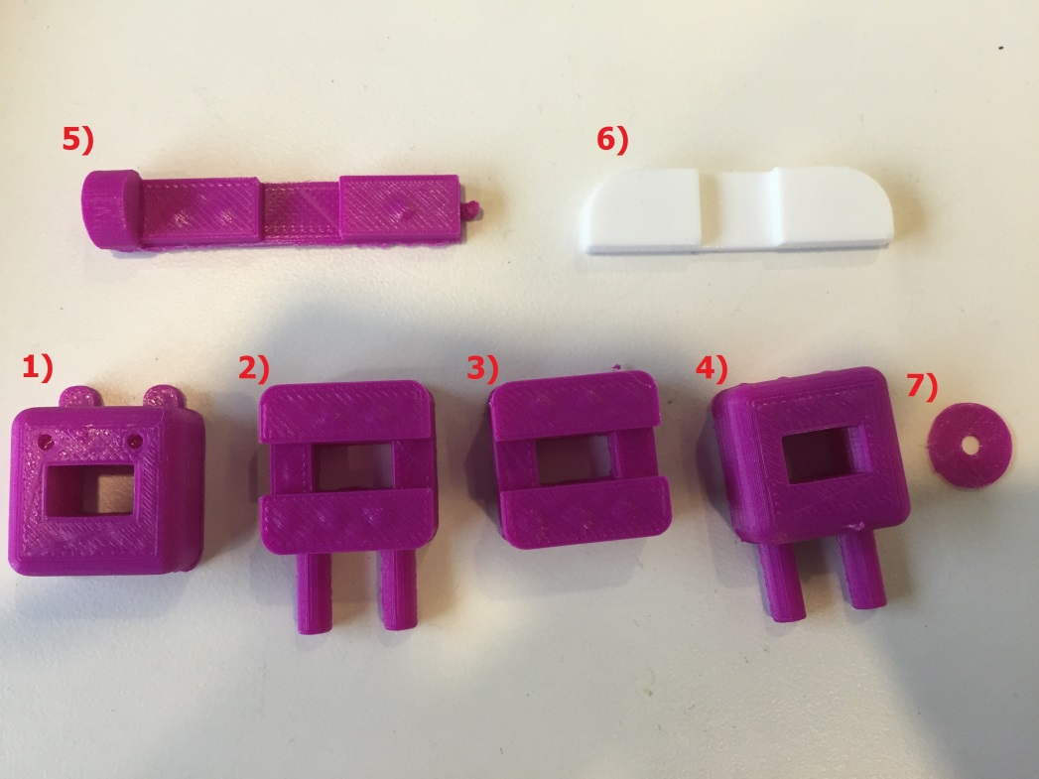

Completed Puzzle:

The puzzle can be completed by doing the following:

1. Slide the nose-to-tail piece (5) through the head piece (1) with the eyes on the same side as the nose
2. Slide the torso piece (2) onto the back of the nose-to-tail piece (5) with the large slot facing towards the tail
3. Fix the wing piece (6) onto the exposed divet of the nose-to-tail piece (5) behind the two front body pieces
4. Slide the abdomen piece (3) onto the nose-to-tail piece (5) behind the wings with the large slot wrapping around the wing piece
5. Slide the butt piece (4) onto the nose-to-tail piece (5) behind all of the previous pieces
6. Put the disk-shaped locking piece (7) onto the tail to hold the back two body pieces in place

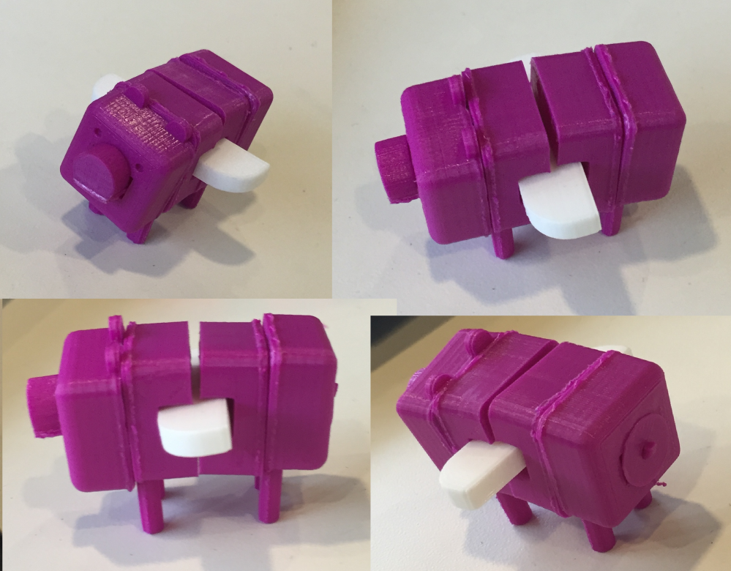

Links to videos:

Assembly- <https://www.youtube.com/watch?v=gdjfluns6EU>

Disassembly- <https://www.youtube.com/watch?v=6BVjsOUMTzQ>